NETWORKING & SYSTEM ADMINISTRATION LAB

**Name: MELBIN M P**

**Roll No: 19**

**Batch: S2 RMCA B Date: 06-06-2022**

Experiment No: 26 Aim

Wireshark **Procedure Commands:**

$ sudo apt update

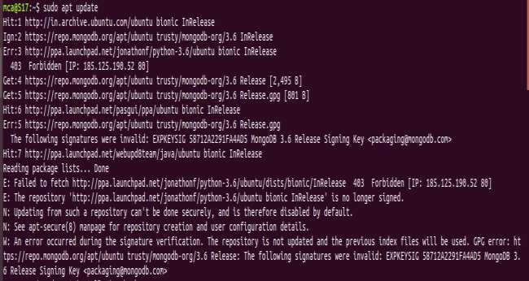

$ sudo apt install wireshark

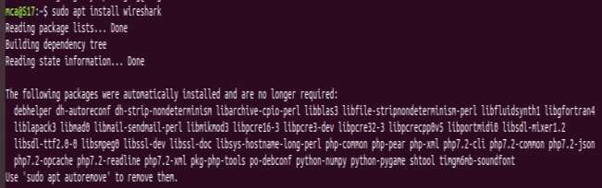

$ sudo adduser $mca wireshark



$ sudo wireshark

